Missing Number?

11 + ____ = 13 3 + ___ = 5 ____+ 5 = 7

2 + _____ = 5 ____+ 7 = 9 3 + ___= 5

Missing Sign

4 9 = 13 2 3 = 5

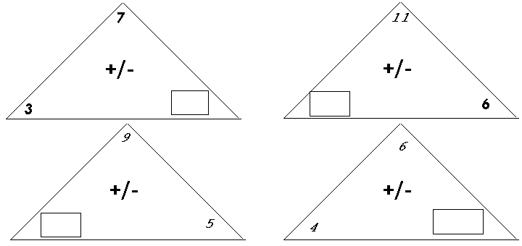5 3 = 2 7 2 = 5

