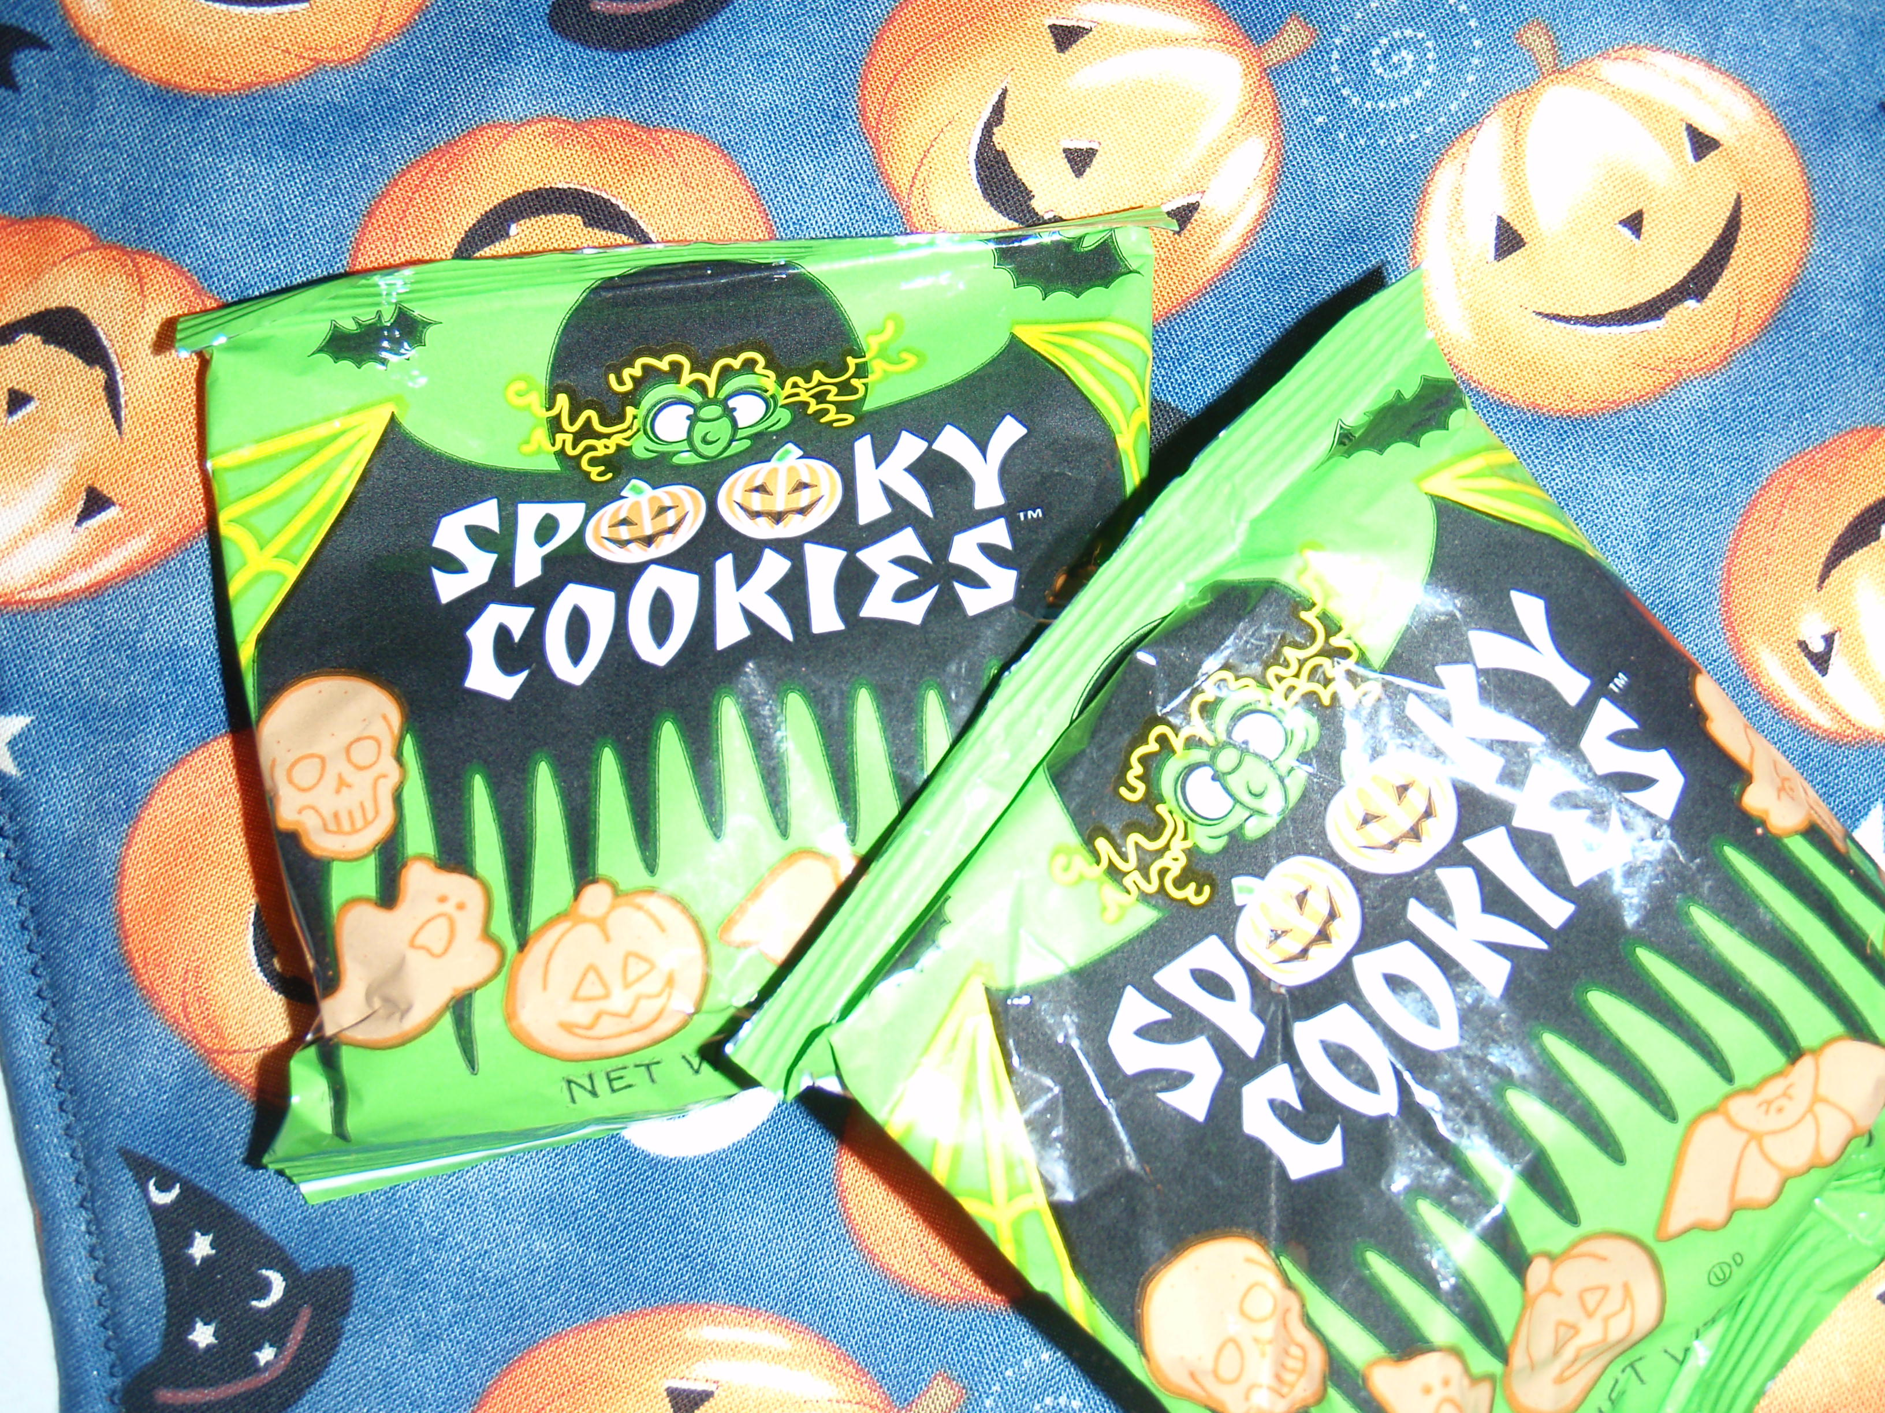
Sort Spooky Cookies

Name _________________________________________Date:____________________

What kinds of cookies are in your bag? Sort your cookies by shape. Count how many you have of each shape. Write how many in the stars.






Copyright @2009 Colleen Gallagher www.teachingheart.net

